QAI LISTING B1102-1a
FALK PANELS CANADA LTD. WALL & ROOF / CEILING PANELS
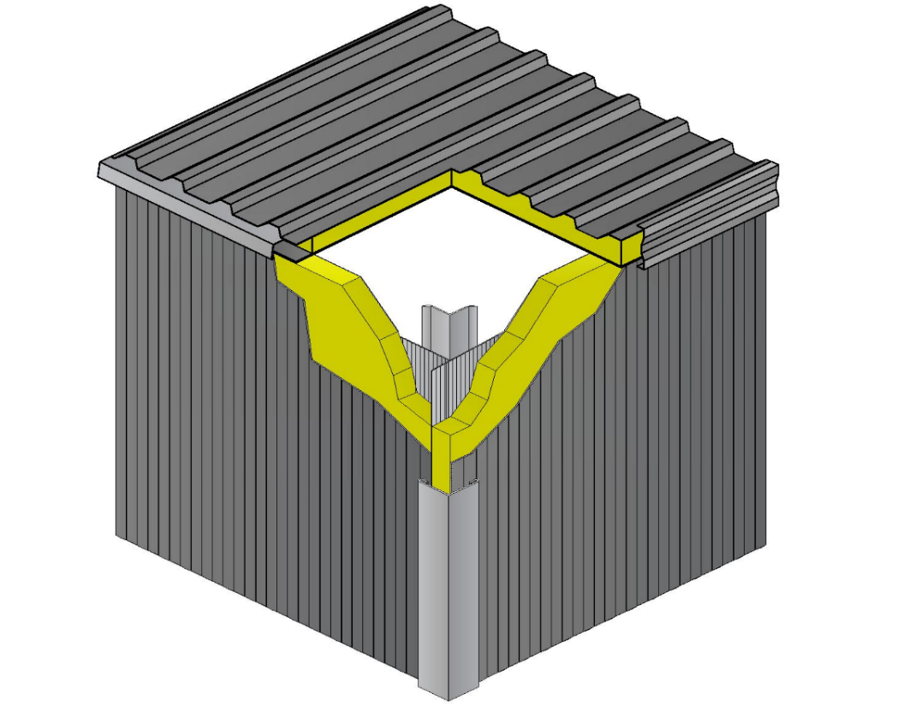
CAN/ULC S138 ROOM CONFIGURATION
1

3
2
4

NUMBER | PART | DESCRIPTION
1 | Roof Panel | Listee: | Falk Panels Canada Ltd.
 |  | Approved Product(s): | GL / 1000 TR / 1000 TR+ Panels
 |  | Facers: | Minimum 0.404 mm (26 Gauge) steel.
 |  | Core: | Maximum thickness 185 mm (7-1/4 inches) Polyisocyanurate foam, maximum density 40 kg/m³ (2.5 lbs/ft³).
 |  | Joint: | Female / Male connection. Optional fasteners and sealants can be used.
 |  | Installation: | Friction fit joints to ensure tight connection. Joint stitching and / or joint sealant is optional.
2 | Wall Panel | Listee: | Falk Panels Canada Ltd.
 |  | Approved Product(s): | 1060 WB / GL / 1000 TR / 1000 TR+ Panels
 |  | Facers: | Minimum 0.404 mm (26 Gauge) steel.
 |  | Core: | Maximum thickness 155 mm (6 inches) Polyisocyanurate foam, maximum density 40 kg/m³ (2.5 lbs/ft³).
 |  | Joint: | Female / Male connection. Optional fasteners and sealants can be used.
 |  | Installation: | Friction fit joints to ensure tight connection. Joint stitching and / or joint sealant is optional.
3 | Joint Flashing | General: | Light Gauge steel flashing mechanically secured to protect room corner joints.
4 | Sprinkler  (Not Shown) | General: | 155ºF (68ºC) activation temperature, pendant style listed sprinklers listed by an approved agency.

